# Pivoting on One Variable - Instruction 2

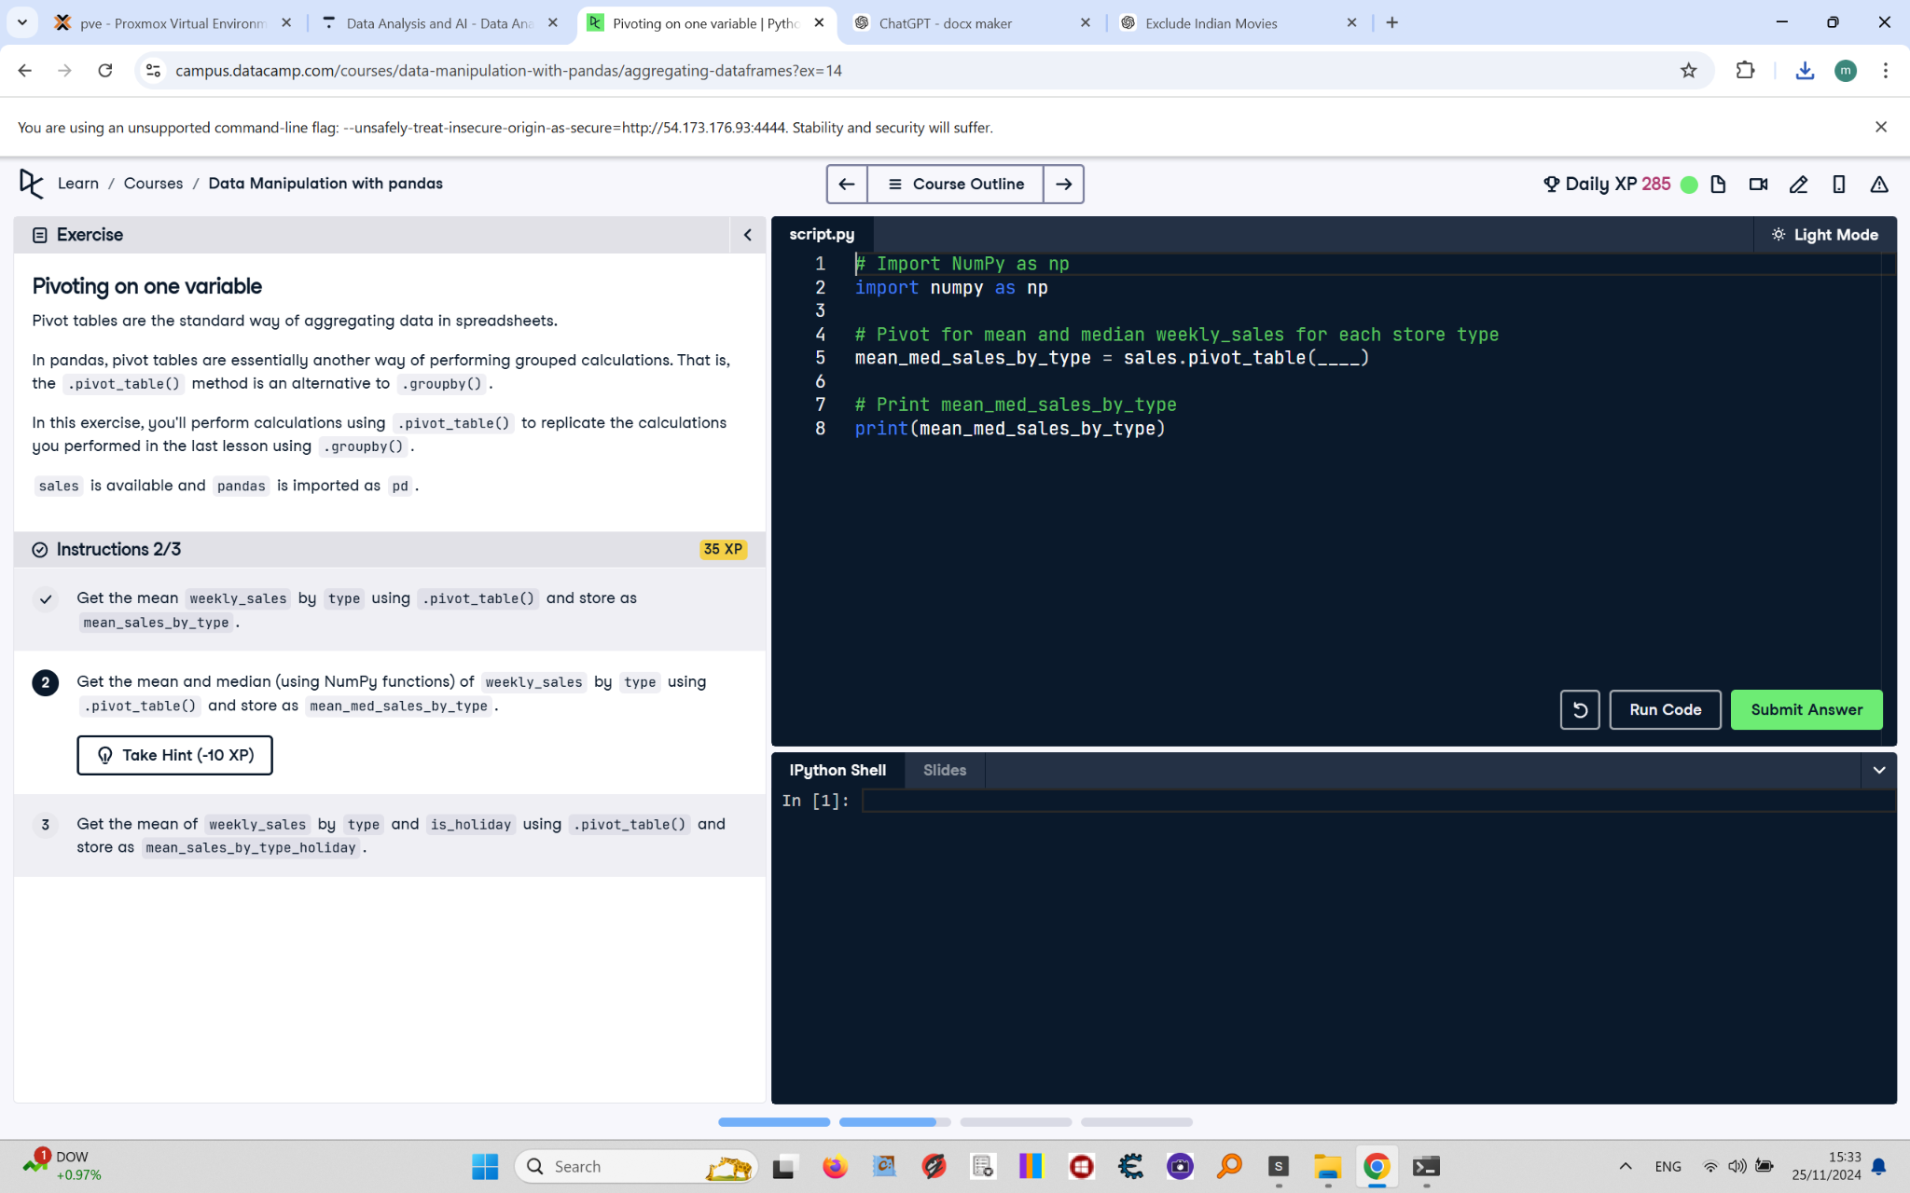

Pivot tables are the standard way of aggregating data in spreadsheets.  
  
In pandas, pivot tables are essentially another way of performing grouped calculations. That is, the pivot_table() method is an alternative to .groupby().  
  
In this exercise, you'll perform calculations using .pivot_table() to replicate the calculations you performed in the last lesson using .groupby().  
  
sales is available and pandas is imported as pd.

## Final Answer - Instruction 2

# Import NumPy as np  
import numpy as np  
  
# Pivot for mean and median weekly_sales for each store type  
mean_med_sales_by_type = sales.pivot_table(values="weekly_sales", index="type", aggfunc=[np.mean, np.median])  
  
# Print mean_med_sales_by_type  
print(mean_med_sales_by_type)